Series 3 - Manipulation of Matrices in MATLAB

Objective: The objective of this practical work is to learn how to: define, manipulate and operate on matrices (2-dimensional vectors).

Exercise 1 :
1. Give instructions (as simple as possible) to produce the matrix A of type 10 × 10 having the following form:

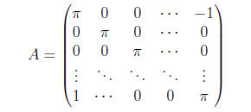

Note:
The elements represented by dotted lines are all zero except on the main diagonal of A.
2. Calculate the first three elements of the main diagonal of A⁻¹ and A⁵

Exercise 2: Manipulating a matrix.
Give the result of each of the following MATLAB instructions:
≫𝐶=𝑑𝑖𝑎𝑔(𝑑𝑖𝑎𝑔(𝑜𝑛𝑒𝑠(3)))
≫𝑘=[1:1:5]
≫𝐷=(𝑜𝑛𝑒𝑠(5)+𝑑𝑖𝑎𝑔(𝑘))+3∗𝑧𝑒𝑟𝑜𝑠(5)

Exercice 3: matrix operations
- Define a matrix M = [1 2; 3 4] then try the following operations in the interpreter:
>>2*M+3
>>M^3
>>M.^3
>> M+M
>> M - M
>>M*M and M.*M
>>M/M and M./M
2. What is the difference between the operators * and .*, ^ and .^, / and ./? what is the result and meaning of each command?
3. Easily create a 54 × 42 matrix containing only 7?
4. Using the predefined MATLAB functions, calculate: the transpose matrix of M (M’), the inverse of M (M⁻¹), the determinant of M, the values and the eigenvectors of M.

Exercise 4: special matrices
- Define the matrices A, B, C and D, where: A is a square matrix of order 3 initialized randomly, B is a 3×2 matrix with all zero values, C is a matrix of dimension 2×3 with values all equal to 1 and D is a square matrix of order 3 with the values all zero except the diagonal equal to 1.
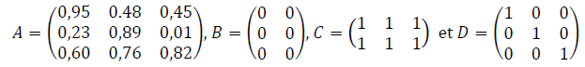
− Give an appropriate nomination for each of these matrices.
− Let 𝑥 be a column vector with values (3 5 7). Replace the diagonal of matrix D with vector 𝑥. As a result you will have:
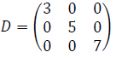
− Create a magic matrix 𝑀 of dimension 4×4. A magic matrix is a matrix where the sum of the elements of each column and the sum of the elements of each row and those of the two diagonals are identical.

