TP1 (Correction)

Exercise 1: Perform the following functions in Matlab:
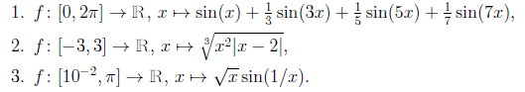

1. x=pi ;
y = sin(x)+sin(3*x)/3+sin(5*x)/5+sin(7*x)/7

2. x=2 ;
y = (x.^2.*abs(x-2)).^(1/3)

3. x=pi ;
y = sqrt(x).*sin(1./x)

Exercise 2: Perform the following function in Matlab:
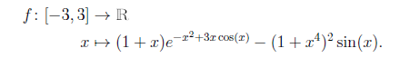

x=-3;
y=(1+x).*exp(-x.^2+2*x.*cos(x))-(1+x.^4).^2.*sin(x)

Exercise 3: Perform the following function in Matlab:
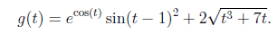
Exercice 4 : Réaliser les fonctions suivantes en matlab :

t=2 ;
y=exp(cos(t)).*sin(t-1).^2+2*sqrt(t.^3+7*t)

Exercise 4:
A. Give MATLAB commands to evaluate the following expressions:
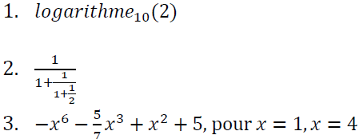

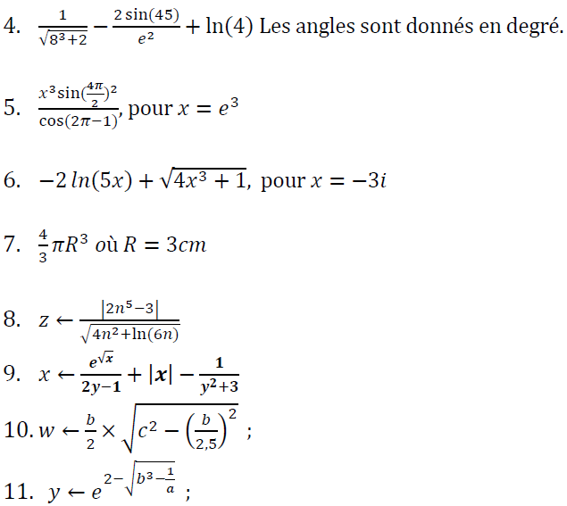
- >> log10(2)
- >> (1)/(1+(1)/(1+1/2))
- >> X=1 ;
>> -x^6-(5/7)*x^3+x^2+5
4 >> x = (1/SQRT(8^3+2))-(2*sin(45)/exp(2))+log(4)
5 >> x= exp(3) ;
>> x^3*sin(4*4pi/2)^2/cos(2*pi-1)
6) >> x= -3*i ;
>> -2*log(5*x)+SQRT(4*x^3+1)
7) >> R= 3;
>> (4/3)*pi*R^3
8) >> Z= abs(2*n^5-3)/SQRT(4*n^2+log(6*n))
9)>> Z= exp (SQRT(x))/2*y-1+abs(x)-1/(y^2+3)
10)>> W= (b/2)*SQRT(c^2-(b/2.5)^2)
11)Y= exp(2-SQRT(b^2-1/a))

B. Give the mathematical expressions equivalent to the following MATLAB instructions:
1. exp (𝑠𝑞𝑟𝑡(𝑥)) /(2∗𝑦−1) + 𝑎𝑏𝑠(𝑥)−1 /(𝑦 ^ 2+3) ;
2. 2∗ 𝑠𝑖𝑛𝑑 (45)/ exp (2) ;
Solution :1)

 