TP4- Graphical representation in MATLAB

Objective: The objective of this practical work is to learn how to represent and analyze data graphically using graphic windows. We also learn how to build a graphical user interface using the MATLAB GUIDE.

Exercise 1: Represent the graphs of the following functions:
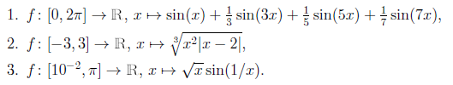

Exercise 2: Represent the graph of the function:

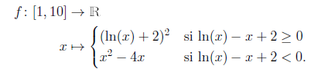

Exercise 3: Represent the graph of the function:
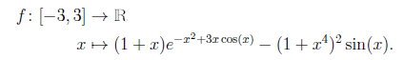

Exercise 4:
1.) Create, using the linspace function, a vector V of 120 points, with values between -13 and 13, then draw the graph of the function 2V² + 5 as a function of V.
2.) Draw the curve corresponding to the function ( ):
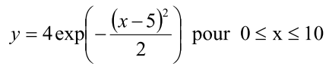
(We will start by creating a value table for x with a step of 0.01).
a) Annotate the axes by indicating the abscissa x in (cm) and the ordinate y in (u.a).
b) Write its legend on this curve.
c) The curve must be red and marked “star” size 3.

Exercise 5 :
Write a Matlab script which represents on the same graph, the functions sin(x), cos(x), sin²(x), sin(x²) in different colors.

Exercise 6:
Draw on the interval [−5,5] the function x2cosx in blue solid line and the function xcosx in red dotted line.

