TP4- Graphical representation in MATLAB

Objective: The objective of this practical work is to learn how to represent and analyze data graphically using graphic windows. We also learn how to build a graphical user interface using the MATLAB GUIDE.

Exercise 1: Represent the graphs of the following functions:
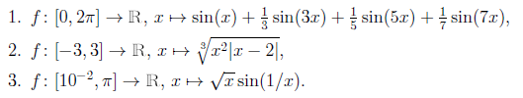

x = 0:0.1:2*pi
y =sin(x)+sin(3*x)/3+sin(5*x)/5+sin(7*x)/7
plot(x,y)

x = -3:0.1:3
y =(x.^2.*abs(x-2)).^(1/3)
plot(x,y)

x = 10^(-2):0.1:pi
y =sqrt(x).*sin(1./x)
plot(x, y)

Exercise 2: Represent the graph of the function:

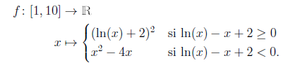

X = 1:0.1:10;

if log(x)-x+2 < 0
y = x.^2-4*x;
else
y = (log(x)+2).^2-4*x;

plot(X,Y)

Exercise 3: Represent the graph of the function:
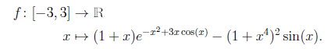
X = -3:0.1:3
y=(1+x).*exp(-x.^2+3*x.*cos(x))-(1+x.^4).^2.*sin(x)
plot(X,Y)

Exercise 4:
1.) Create, using the linspace function, a vector V of 120 points, with values between -13 and 13, then draw the graph of the function 2V² + 5 as a function of V.
2.) Draw the curve corresponding to the function ( ):
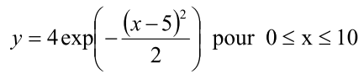
(We will start by creating a value table for x with a step of 0.01).
a) Annotate the axes by indicating the abscissa x in (cm) and the ordinate y in (u.a).
b) Write its legend on this curve.
c) The curve must be red and marked “star” size 3.

1.)
V=linspace(-13,13,120);
plot(V,2*V.*V+5)

2.)
a) b) c)
>> X=0 :0.01 :10
>> x=0:0.01 :10;
>> y=4*exp(-(x-5).*(x-5)/2);
>> plot(x,y,'r*')
>>xlabel(cm)
>>ylabel(u.a)
>>legend(loi gaussienne)

Exercise 5 :
Write a Matlab script which represents on the same graph, the functions sin(x), cos(x), sin²(x), sin(x²) in different colors.

x=[-2*pi:0.01:2*pi];
plot(x,sin(x),'ro', x,cos(x),'g.',x,(sin(x)).^2,'ms', x,sin(x.^2),'db') ;

Exercise 6:
Draw on the interval [−5,5] the function x2cosx in blue solid line and the function xcosx in red dotted line.
>> x = [-5:0.01:5];
>> y = x.^2.*cos(x);z = x.*cos(x);
>> plot(x,y,’b-’,x,z,’r:’);

