– “Programming tools for mathematics” exam – 1h
Unauthorized handwritten documents and course notes

Name : ……………………………………………………………………………………….

First name :……………………………………………………………………………………

Group :……………………………………………………………………………………

Exercise 1: Give the MATLAB/SCILAB result for each of the following commands:
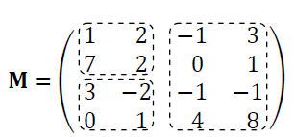

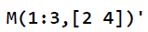

Exercise 2: Give the results of the following expressions:

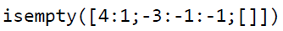

– “Programming tools for mathematics” exam – 1h
Unauthorized handwritten documents and course notes

Name : ……………………………………………………………………………………….

First name :……………………………………………………………………………………

Group :……………………………………………………………………………………

Exercise 3: Consider the following function:

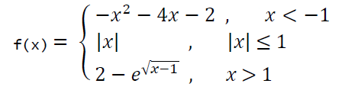
Draw the curve of the function f in the interval [-4, 4]?
Draw the curves of these three sub functions in the same figure in the interval [-4, 4]?

