Chapter 1 - Summary of Key Results in Signal Theory

📘 Chapter 1

Summary of Key Results in Signal Theory

1. Introduction
Understand the difference between signal theory and signal processing.
- Signal theory aims at the mathematical description of signals.
It provides mathematical tools to characterize signals—such as whether they are causal, deterministic, continuous, or discrete. It forms the theoretical foundation of signal processing.
- Signal processing is a field focused on developing and studying techniques for processing, analyzing, and interpreting signals to extract the maximum amount of information.

1.1. Main Functions of Signal Processing
To manipulate the information contained in a signal, various operations can be applied, such as:
- Analysis: Isolating the key components (parameters) of a complex signal to better understand its nature.
- Measurement: Estimating the value of a characteristic quantity associated with a signal.
- Filtering: A well-known operation that removes unwanted components from a signal.
- Regeneration: Restoring a signal that has been distorted to its original form.
- Detection: Extracting a useful signal from background noise.
- Identification: This is a process that enables the signal to be classified.
- Encoding: Translating the signal into digital form.
- Synthesis: The inverse of analysis—reconstructing the signal by combining its parameters.
- Modulation and frequency shifting: Adapting a signal to the frequency characteristics of a transmission channel.

1.2. Application Domains of Signal Processing
Signal processing has a wide range of applications, including:
- Speech processing: Speech and speaker recognition
- Aerospace and automotive industries
- Telecommunications: Mobile phones, Optical and satellite communications
- Biology and medicine: ECG, ultrasound imaging
- Radar and sonar systems
- And many others…

2. Definition of a Signal
A signal is a physical quantity that varies over time and conveys information.
Examples include: electrical current, sound waves, light waves, etc.
In practice, a signal is often provided by a sensor that measures a physical quantity (sound, speech, temperature, pressure, etc.) and converts it into an electrical current or voltage.
Mathematically, a signal is defined as a function of time: t→f (t)
Where t is a real variable representing time.
2.1. Classification of Signals
• Temporal or Phenomenological Classification
- Deterministic signals: Their time evolution can be perfectly described using simple mathematical models.
They may be represented using real or complex functions, or even distributions like the Dirac impulse.
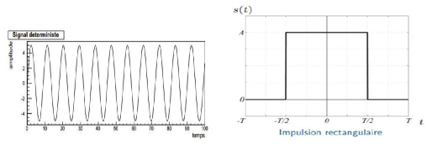
- Random (Stochastic) signals: Their mathematical model is unknown, and their evolution is unpredictable.
They are described statistically—using variance, mean, and probability laws.
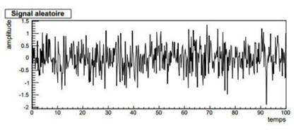

Among deterministic signals:
- Periodic signals: Their form repeats regularly over time
- Aperiodic signals
Among random signals:
- Stationary signals: Statistical properties do not change over time
- Non-stationary signals: Their statistical behavior evolves with time
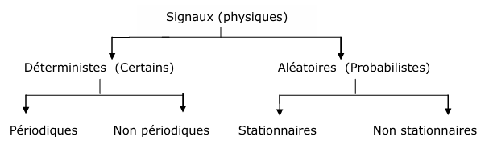

- Morphologicalclassification
Depending on whether the signal x(t) or the variable t is continuous or discrete (t = kT), four types of signals can be distinguished:
- Analog signal: a signal with continuous amplitude and continuous time.
- Quantized signal: a signal with discrete amplitude and continuous time.
- Sampled signal: a signal with continuous amplitude and discrete time (the signal values are available only at specific time instants).
- Digital signal: a signal with both discrete amplitude and discrete time (it is a sampled signal whose values are encoded).
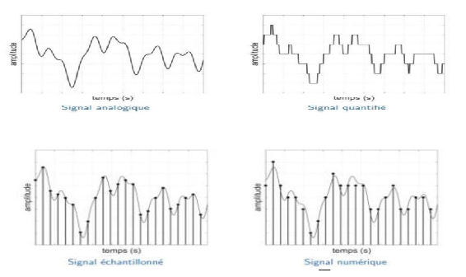
- EnergyClassification:
There are two main classes of (deterministic) signals:
- Energy signals: signals that have finite energy over all time.
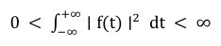
- Power signals: signals that have finite and non-zero average power over time.
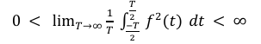
The first category includes transient-type signals, whether deterministic or random (e.g., a square or Gaussian pulse).
The second category includes steady-state signals, such as periodic deterministic signals and stationary random signals.
- Frequency or Spectral Classification:
Spectrum of a signal: the spectrum of a signal is the representation of its amplitude, phase, energy, or power as a function of frequency f in Hertz (Hz).
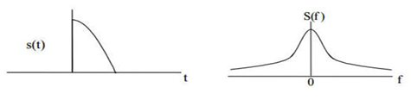

Bandwidth or Spectral Width:
It is the range of frequencies occupied by the spectrum of a signal. This range is called the bandwidth
. 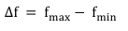
Different types of signals can be distinguished:
- Narrowband signals, whose bandwidth is relatively small
- Wideband signals, whose bandwidth is relatively large or even infinite
- Low-frequency (LF) signals, whose bandwidth is centered around relatively low frequencies.
- High-frequency (HF) signals, whose bandwidth is centered around relatively high frequencies.

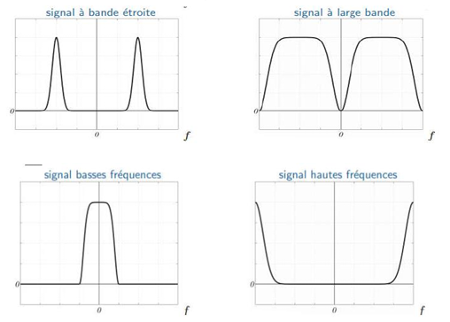

A signal whose spectrum is zero outside a specified frequency band BB is called a band-limited signal or a signal with bounded spectral support.

2.2. Properties of Signals
- Causality:
A signal f (t) is said to be causal if it is equal to zero for all negative time values, i.e., f (t) =0for all t<0t < 0.
- Even (Symmetric) Signal:
A signal is even if for every t, f (−t) =f (t)
this means the signal is symmetric with respect to the vertical axis.
- Odd (Antisymmetric) Signal:
A signal is odd if f (-t) = -f (t).
It has symmetry about the origin.
- Vertical Translation (Offset):
A shifted signal is defined as g(t)= f(t) + a, where a is a constant vertical offset
- Delayed Function (or Horizontal Translation):
The function g(t) is the function f(t) delayed by t0 (delay) if, for all t, we have:
G (t) =f (t−t0)
This means the signal f (t) is shifted to the right along the time axis by t0 units.
3. Common Signals 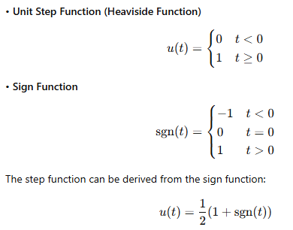

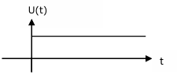

Step function (fonction echelon)

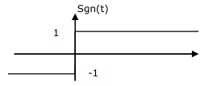

Sign function (fonction signe)

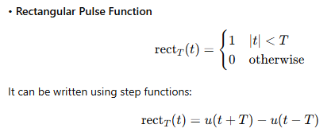

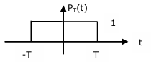

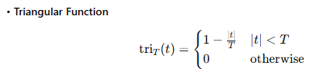

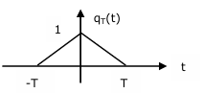

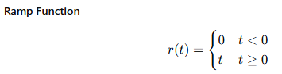

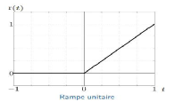

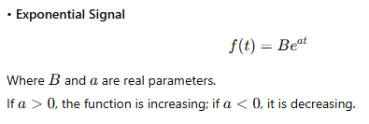

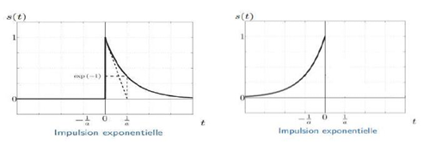

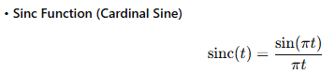

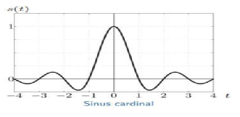

3.1. Dirac Delta Function

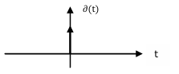

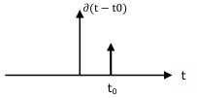

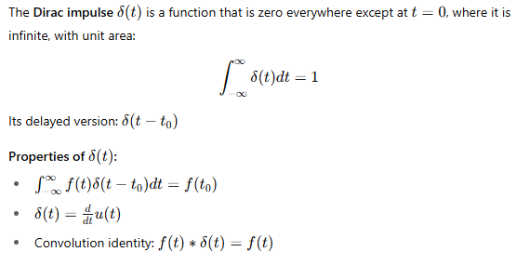

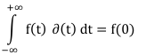

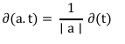

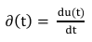

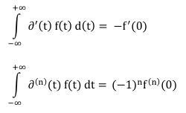

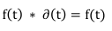

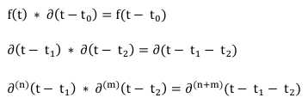

• Dirac Comb
