**Duration : 1h30 date: 21-01-2024**

**Note:**

1. Answers can be provided in either Algorithmics or C language; both are acceptable.
2. The algorithms or C programs written must include the variable declaration section.

**Exercise 1: (5 pts)**

Write an algorithm/C program that displays the biggest and the smallest divisors of a given number. (Example: biggest and smallest divisor of **10** are respectively **5** and **2**, the number itself and the number 1 are not included).

|  |  |
| --- | --- |
| **Solution**  #include <stdio.h>  int main() {  int number, smallest, biggest;  // Input the number  printf("Enter a number: ");  scanf("%d", &number);    smallest = number;  biggest = 1;  // Find the divisors  for (int i = 2; i <= number / 2; i++) {  if (number % i == 0) {  smallest = i;  biggest = number / i;  break;  }  }  if (smallest!=1)  { printf("The smallest divisor of %d is: %d\n", number, smallest);  printf("The biggest divisor of %d is: %d\n", number, biggest);  }  else printf("No divisors other than the number 1 and the number itself ");  return 0;  } | **(0.5pt)**  **(1pt)**  **(1pt)**  **(0.5)**  **(0.5)**  **(0.5)**  **(0.5)**  **(0.5)** |

**Exercise 2: (5 pts)**

- Write an algorithm/C program that:

1- Asks the user if he wants to calculate the area of a circle or a rectangle.

2- Allows the user to input data, including the width and length for a rectangle, and the radius for a circle.

3- Displays the result.

- Provide a solution using a flowchart.

|  |  |
| --- | --- |
| **Solution**  #include <stdio.h>  int main() {  int choice;  printf("Choose the shape to calculate the area:\n");  printf("1. Circle\n");  printf("2. Rectangle\n");  printf("Enter your choice (1 or 2): ");  scanf("%d", &choice);  if (choice == 1) {  float radius, area;  const PI=3.14;  printf("Enter the radius of the circle: ");  scanf("%f", &radius);  area = PI * radius * radius;  printf("The area of the circle with radius %.2f is: %.2f\n", radius, area);  } else if (choice == 2) {  double width, length, area;  printf("Enter the width of the rectangle: ");  scanf("%f", &width);  printf("Enter the length of the rectangle: ");  scanf("%f", &length);  area = width * length;  printf("The area of the rectangle with width %.2f and length %.2f is: %.2f\n", width, length, area);  } else {  printf("Invalid choice. Please enter 1 for circle or 2 for rectangle.\n");  }  return 0;  } | (0.5pt)  (1pt)  (1pt)  (0.5pt) |

(2pts)

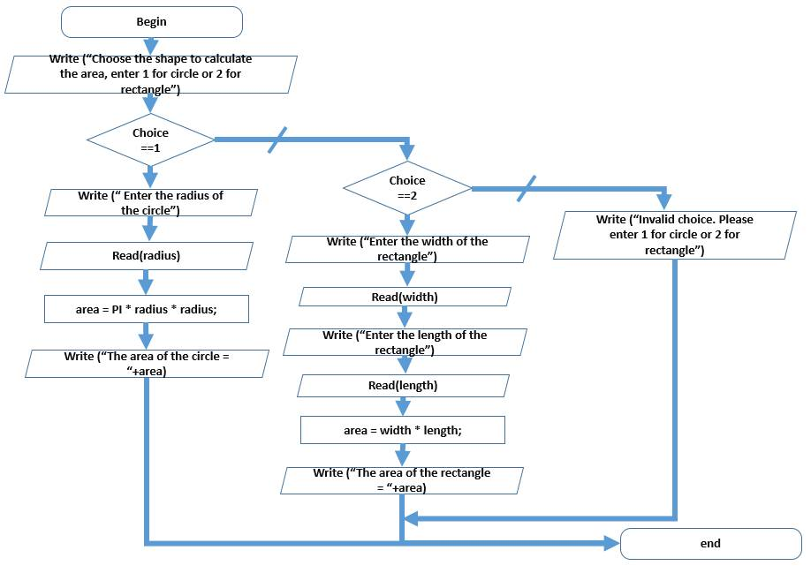

**Exercise 3: (5 pts)**

Write an algorithm/C program that calculates the number of ‘0’ (zeros) in the lower part of a square matrix regarding its first diagonal.

**Solution**

#include <stdio.h>

int main() {

int n=5;

int matrix[n][n];

int zeroCount = 0;

for (int i = 1; i < n; i++) {

for (int j = 0; j < i; j++) {

if (matrix[i][j] == 0) {

zeroCount++;

}

}

}

printf("Number of '0' in the lower part regarding the first diagonal: %d\n", zeroCount);

return 0;

}

**Exercise 4: (5 pts)**

Write an algorithm/C program that:

1. Search for a given letter in one dimension array.
2. Move all its occurrences to the left and shift the others to the right.

#include <stdio.h>

int main() {

int n, i, j;

char target;

char arr[n];

Partie declaration bien faite : 0.5

printf("Enter the target letter to search for: "); 0.5

scanf(" %c", &target);

for (i = 0; i < n; i++) {

if (arr[i] == target) {

// Shift elements to the right 1pt

for (j = i; j > 0; j--) {

arr[j] = arr[j - 1];

} 2 pts

arr[0] = target; 0.5

}

}

return 0;

}

L’agencement 0.5

Remarque : L’enchainement est important, c’est-à-dire une instruction mal placée n’est pas comptabilisée.