**Series 2- Vectors in MATLAB Objective**: The objective of this practical work is to learn how to: define, manipulate and operate on vectors in MATLAB.

**Exercise 1:**

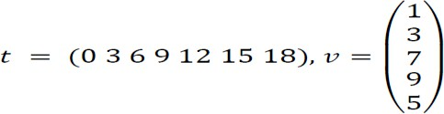1. Let k be a vector defined from 3 to 5 with a step of 2, N a vector defined from 1 to 2 with a step of 1 and the vector F which is the horizontal concatenation of k and N. Define the vectors K, N and F in MATLAB and display the results obtained;

2. Define the following vectors t (row-vector) and v (column-vector):

Modify the values of the elements in the indices: 5 and 7 by the value -3 of the vector t.

𝑡 = (0 3 6 9−3 15−3);

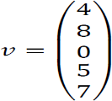3. Modify the values of the elements in the indices: 1 to 3 by the values 3, 5 and 9 respectively, then the elements of indices 4 and 5 by 8 and 10 of the vector v;

4. Let 𝑣1 =(1 2 3 4), 𝑣2 =(7 6 0) be two row vectors. Create a row-vector v3 of size 10 by concatenating vector v1 of size 4 then two vectors of size 3 which correspond to vector v2;

𝑣3=(1 2 3 4 7 6 0 7 6 0)

5. Let x and y be column vectors:

Define z which is a concatenation of x and y:

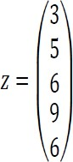

- Insert the value 2 in the first position of the vector z, the value 20 in the last position of the vector and the value -7 in the 3rd position of z;

- Delete the elements in positions 2 and 4;

- Order the elements of vector z in ascending order;

**Exercise 2:**

1. Construct the following vectors in MATLAB:

𝑢1=(3 6 9…27 30)

𝑢2=(−𝜋/2 –𝜋/4 0 𝜋/4 𝜋/2 …11𝜋/4 3𝜋)

𝑢3=(0 1 49…81 100)

**Exercise 3:**

1. Propose the MATLAB instructions which allow you to define the following three vectors:

𝑣1=(1 2 3 4 5 6 7 8 9 10), 𝑣2=(−1.5,0,1.5,…,4.5,6), 𝑣3=(1,1/4,1/9,1/16,1/25,…,1/81,1/100)

2. Create a vector v which contains all the elements of v1, v2, v3 consecutively;

3. Show the elements of v from the 11th position to the 5th position;

# Exercise 4:

# Let the row vector be 𝑣=(-1 12 0 15 23 50 1 8).

# 1. Calculate and display the sum, average, product of the elements of v;

# 2. Calculate and display the minimum and maximum in v;

# 3. Reverse the vector v (display the elements of the vector in reverse order);

# 4. Find and display values greater than 10 in v.